

|  |
| --- |
| Recommendation System for Online Retailers |
|  |
| R Shiny App Report  Authored by: Nikeeta Brijwasi  Shefali Jain  Vijaya Rani  Sudarshana Singh |

Business Problem: Recommender systems are gaining tremendous popularity across companies, such as Amazon and Netflix, due to their effectiveness and efficiency in helping users filter through enormous numbers of items and in helping enterprisers increase their sales. As business analyst students , we chose our project to make recommendation engine to help online retailers who are working to make the business more profitable by providing customized recommendations to their customers which will help in increasing the probability to cross-sell, establish customer loyalty and increase revenue by targeted advertisements and improving customer satisfaction. Higher customer drop-off rates across categories is one of the top concerns identified by the online retailers and we are provided with historical transactional data of 1 year to come up with a recommendation model to be used for customized campaigns and advertisements.

Analytics Problem: The dataset consists of customer level transactional data along with product, country & order date information to predict the set of products that a specific customer frequently buys together. The app will take inputs such as customer id, country, product categories to give information about which products are frequently ordered together and what is the probability of certain items being ordered by the customer based on his past purchases so that these recommendations can be given to the customer in form of email campaigns and ads on the website. This recommendation engine could benefit the retailer by increase in basket size of the customers(quantity per order per customer), increase in repeat purchase, decrease in drop-off rates, increase in sales & revenue. Our analysis would have been richer if we had other important customer demographic data and a long duration of transactional data spread over 3-4 years

Data: The data is from an e-commerce retailer based in United Kingdom, found through Kaggle and UCI repository. This is a transactional data set for orders placed between 01/12/2010 and 09/12/2011 having product and order information. We cleaned the data starting with running the Data Quality Report to check for missing values. There were 25% missing values for Customer ID which we deleted. Also, the records with negative price and quantity were removed from the dataset. We coerced the character variables to factor variables and normalized the numeric features. We created a new column which tells the order amount from the number of units ordered and the unit price. There were 387884 records with 4338 unique customer IDs and 4070 SKUs with 423 product categories.

After cleaning, processing and performing EDA we found the following insights and trends in the data. 95% of the orders were placed in the UK. The most orders were placed in the month of November and within the week Thursday had the maximum orders placed across all countries. In UK customers place the maximum orders around 12 in the afternoon on all days of the week, while Germany and France show more variation in these times though the peak is between 10 am to 2 pm. The unit price varies from $0 to $700 but the majority of orders have products with prices below $6. With increasing unit price the number of bulk orders decrease.

Methodology Selection: A Recommendation model is a Predictive model which generally uses either content-based filtering or user-based collaborative filtering. Content-based filtering requires more information about customers interests and it is based for individual users, while user-based collaborative filtering is focused on similarity between different user’ interests based on their common purchase pattern. For limited set of data, using content-based filtering didn’t make sense due to the unavailability of customer interests & demographic data. User-based collaborative filtering & association mining approach was used to first cluster the customers based on similar purchase pattern i.e., RFM segments (Recency-Frequency-Monetary) and then used Market Basket Analysis approach to recommend the products to a specific user based on the products frequently bought together in that cluster. R provided us with built-in functions and libraries to make the model fast and efficient. We chose to do this analysis in R because it has built-in functions and libraries that make the model fast and efficient. Our data was also of appropriate size to not face any computational challenges in R.

Model Building: Post pre-processing & cleaning the data, we used unsupervised hierarchical clustering model to segment the customers based on common purchase and spending patterns. By performing RFM analysis, we initially identified 8 customer clusters which can be further used to identify products that can be recommended to a customer in that cluster. But by observing the centroids of these clusters, we couldn’t find any difference between 3 clusters, so we calibrated our model to go ahead with 5 unique customer clusters.

We then imputed these clusters in our preprocessed file to assign cluster to each customer to perform Market Basket Analysis. This model uses Association rule miningon the different clusters to find out the products that should be recommended to these customers in that cluster. This will be achieved by grouping products that are ordered together most frequently to predict what is the probability of these products being ordered together in the future.

Functionality: Our Shiny app gives an interface to the stakeholders for 3 different business use-cases based on customer transactional data. It can provide

1. Product specific recommendations- This tab takes “Product Category” as input and product categories which have high affinity of being bought together with the input category will be shown as output. This could be used by the retailer to formulate Product specific recommendations to bundle products and give targeted discounts at product level
2. Customer specific recommendations- This tab takes “CustomerID” as Input and the output would be the RFM cluster that he belongs to and the product category that should be recommended to the customer basis his/her cluster.
3. Cluster specific recommendations- This tab takes Cluster as input and displays the best selling product of that cluster. This can be used for mass marketing campaigns by the company

R provides us built-in packages like tidyr, knitr, data.table, dplyr, stringr packages for RFM analysis which enabled us to know which products have the highest affinity to each other. Arules, arulesviz, tidyverse, readx and lubridate packages were used for Market Basket analysis to build an efficient model providing recommendations with highest accuracy.

Conclusion

Clustering: We came up with 5 broad customer clusters which will help the retailers build mass marketing campaigns using the characteristics of the customers in that cluster and the type of products bought together in the past. These clusters were formed on the basis of common purchasing habits, order frequency and recency of orders.

Market Basket Analysis: These 5 customer clusters were then used to find the products frequently bought together in that given cluster, this product information can then be used by retailers to build product & customer specific recommendations explained in functionality section to send mass emails to a customer cluster based on their similar purchasing behavior and preferences.

Exhibits

Exhibit A Data dictionary

|  |  |  |
| --- | --- | --- |
| Variable | Type | Description |
| Invoice No. | Numeric | Unique identifier for order |
| Stock code | Numeric | Unique identifier for product |
| Description | String | Product detail |
| Quantity | Numeric | Count of products ordered in one order |
| Invoice Date | Date | Date of order placed |
| Unit Price | Numeric | Total monetary amount for an item |
| CustomerID | Numeric | Unique identifier for customer |
| Country | Numeric | Country where order was placed |
| Category | String | Category of product |
| Total $ | Numeric | Total amount per order |

Exhibit B Number of orders for top 4 countries

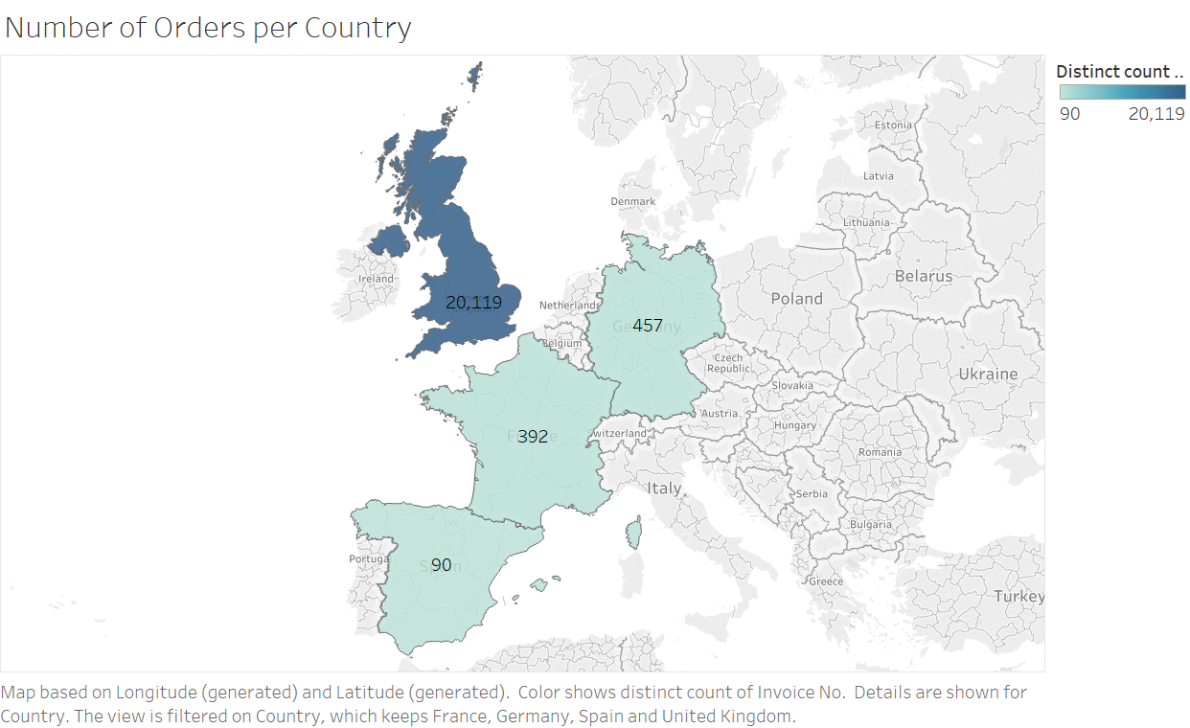

Exhibit C Customers have placed maximum orders in the month of November

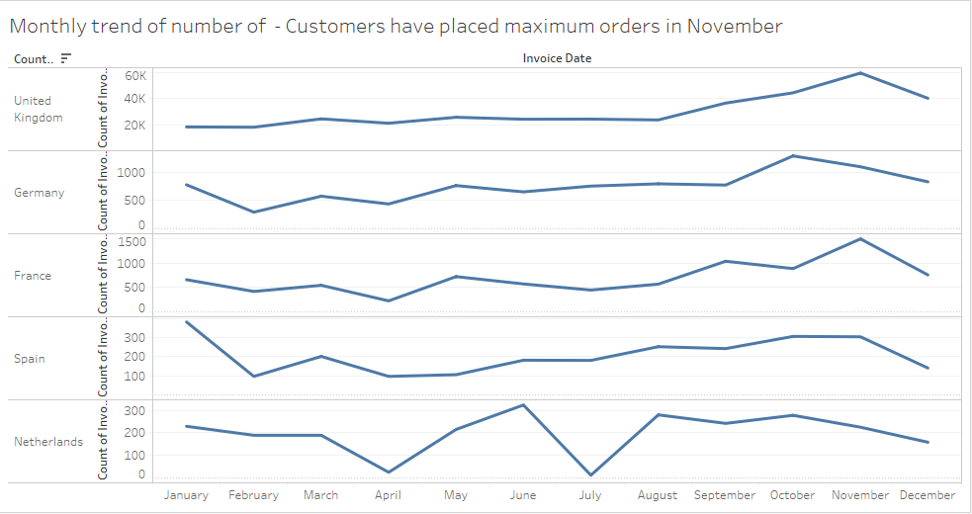

Exhibit D Hourly order trends

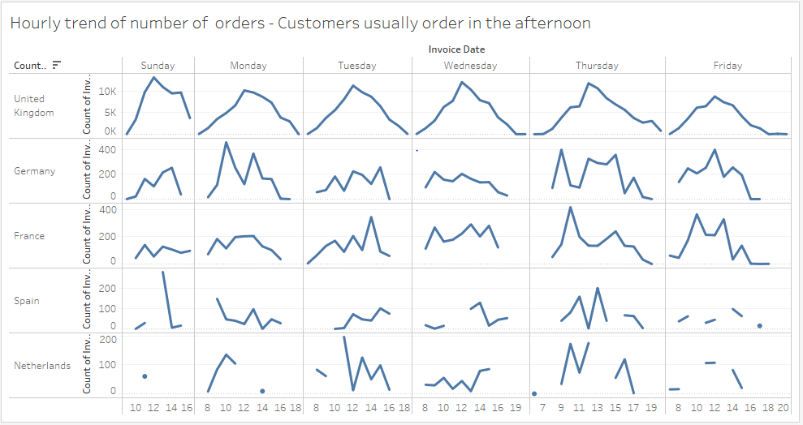

Exhibit E Daily order trends

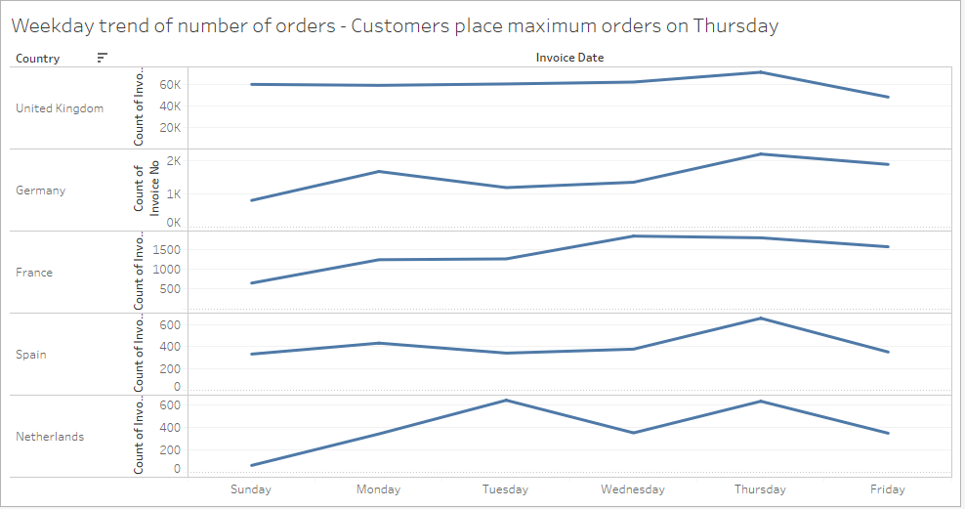

Exhibit F Number of orders per unit price

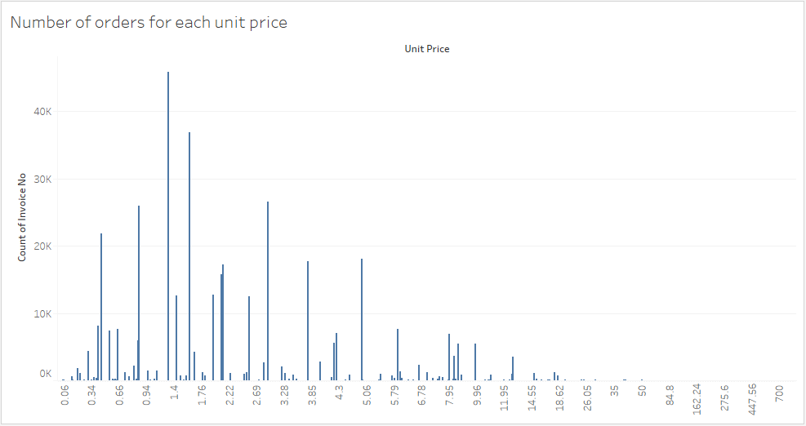

Exhibit G Quantity ordered per unit price

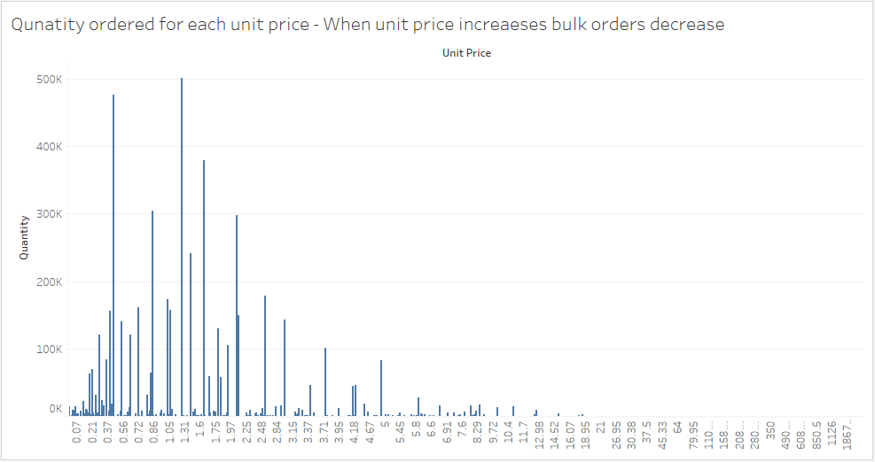

Exhibit H Dendrogram of clusters based on RFM Analysis

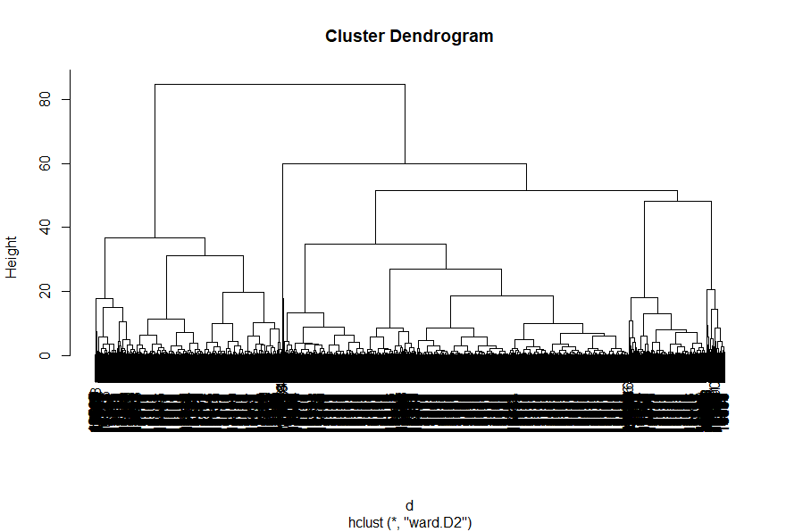

Exhibit I Histogram of Frequency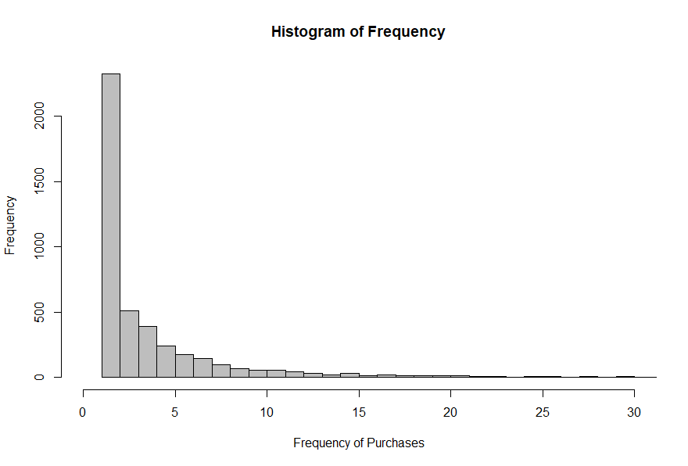

Exhibit J Histogram of Monetary

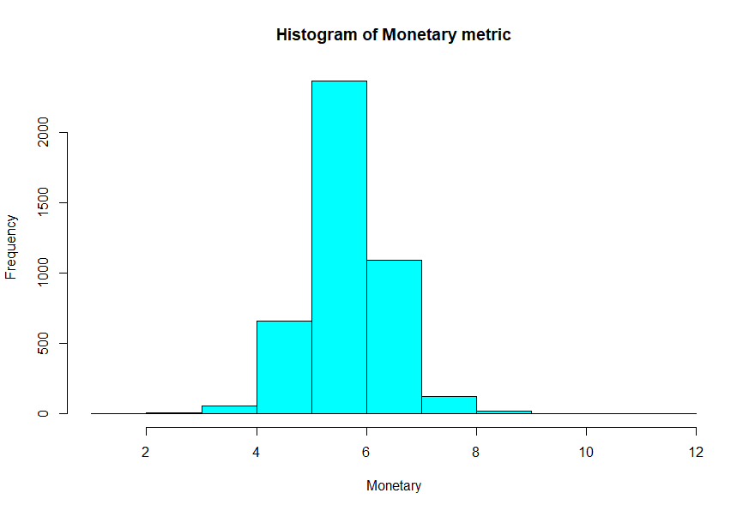

Exhibit K Histogram of Recency 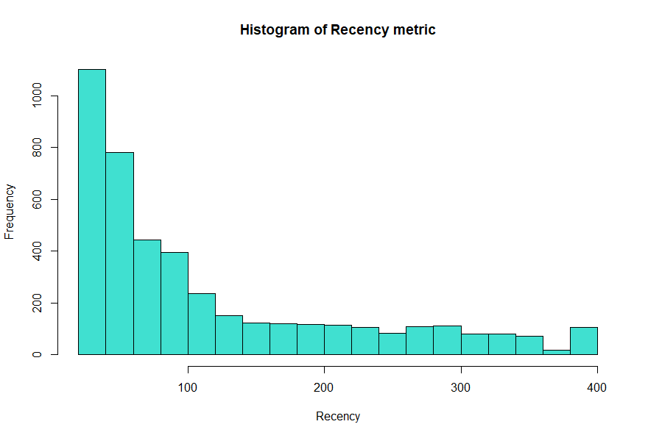

Exhibit L Relative Item Frequency Plot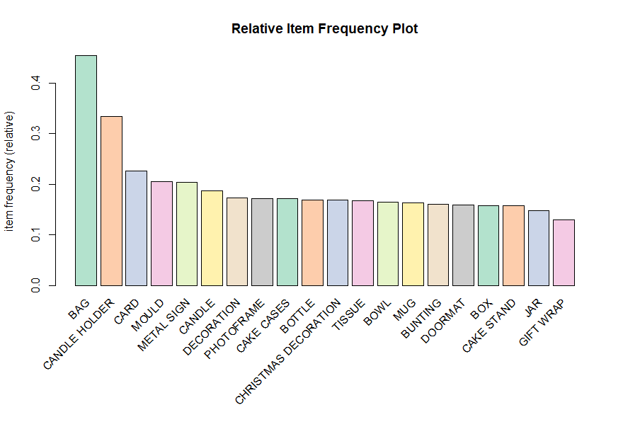

Exhibit M Customer cluster description

|  |  |
| --- | --- |
| Cluster Name | Cluster Description |
| Upscale Buyers | Buy most expensive items (high price affinity), but infrequent, low vertical diversity |
| On the brink customers | Inactive customers with lowest spend and have the highest probability of lapsing |
| Average Joe | Active buyers with medium frequency and spend |
| Bottom of the Barrel | Infrequent single time buyers with lowest GMV  and transaction frequency, no high value purchase |
| Top of the Hill | Most frequent and active transactors  with highest revenue contributing cluster |

Exhibit N Shiny App GUI

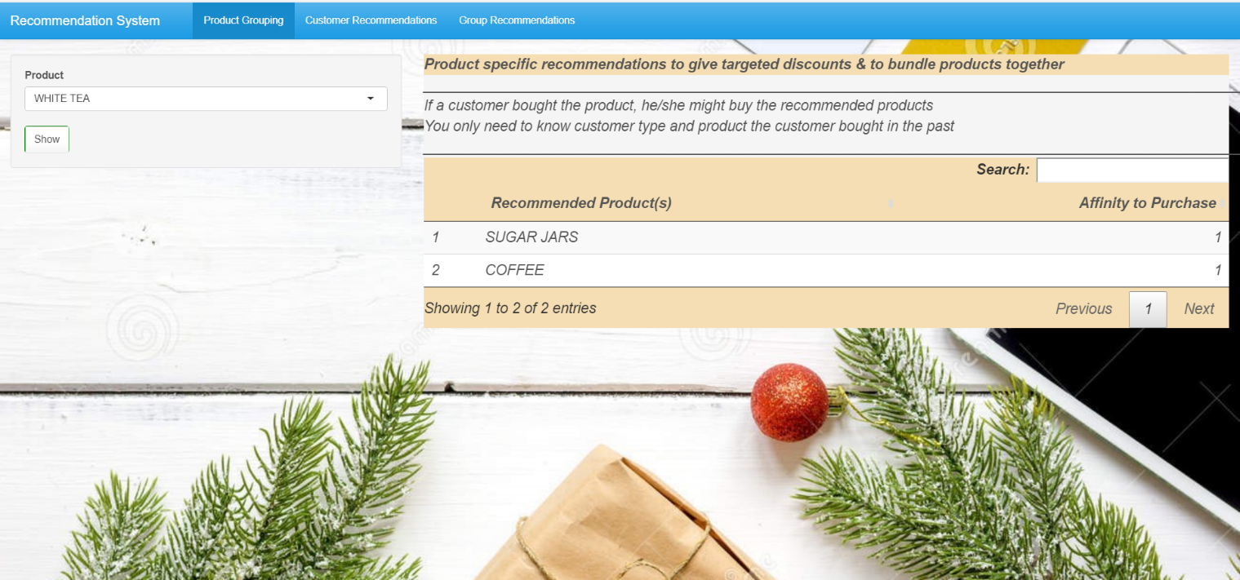

Exhibit O Customer Recommendation Tab

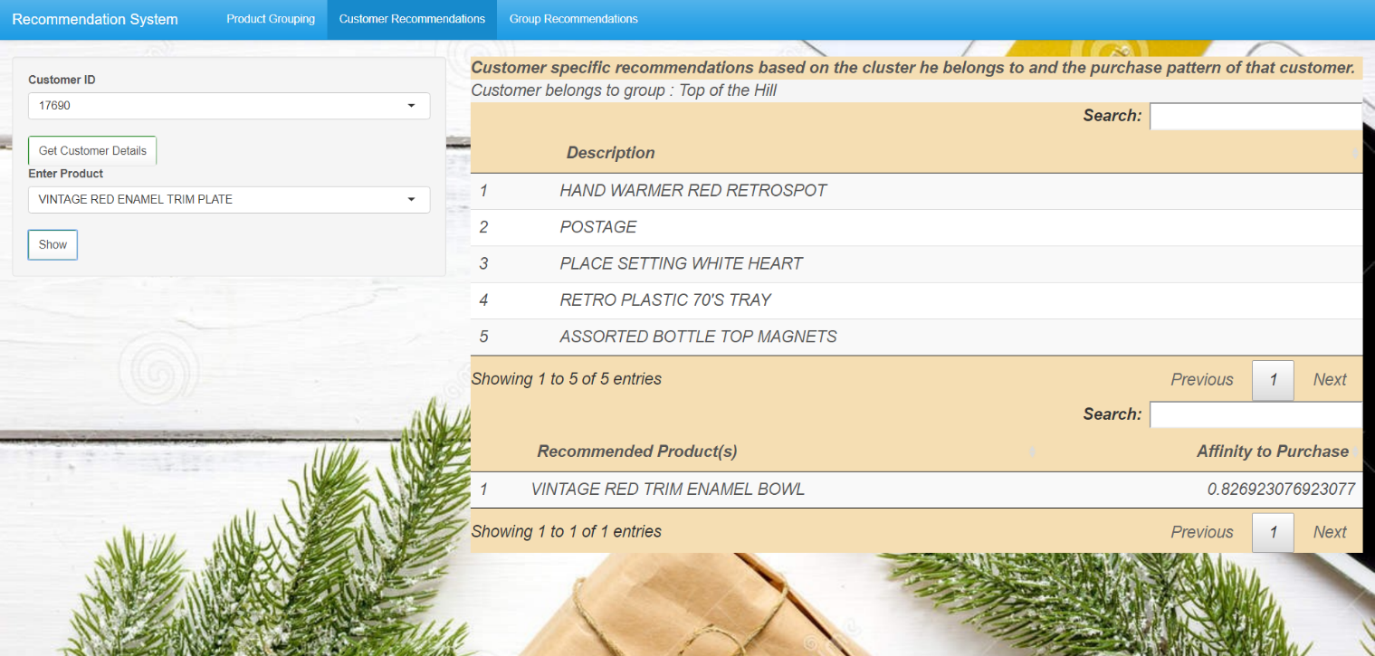

Exhibit P Group Recommendation Tab

